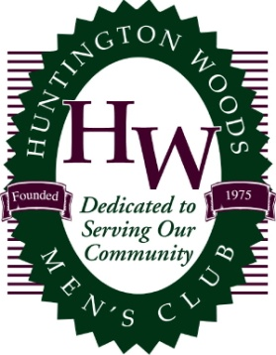

**2024 Description:**

**Restrictions:**

#### Gift Information

**Gift Value: ___________________**

**When is the Gift Available? ________________**

**Select donation type below:**

🞏 Gift

🞏 Tickets

🞏 Donor supplied Gift Certificate or 🞏 HWMC to create Gift Certificate

*As a matter of privacy we do not disclose auction winner contact information or bid amounts. Thank you!*

#### Donor Information MUST BE COMPLETED ON FORM

**Gift Donated by**:

**Donor/Contact Name**:

**Company Name:**

**Address**:

**City**: **State:**  **Zip**:

**Phone**:

**E-mail**:

# 2024 HWMC Service Auction

## Gift Donation Form

### Huntington Woods Recreation Center

### April 17th- 20th, 2024

**Please submit gift donation form by February 24th to the Gift Chair**

***Christopher Marshall*** *- Ph: 810.358.1614 25525 Hereford Dr, Royal Oak, MI 48067 hwmc.gift.chair@gmail.com*

### Catalog

### Number

### Tag Number

**Tangible Item y/n**

### Procurement Number